EXP NO : 2
HOTEL ROOM BOOKING

Aim
To develop a Hotel Booking webpage that allows users to enter their name, select a room type, enter the number of guests, and book a room.
Procedure
- Create a webpage using HTML.
- Add an input field for the customer's name.
- Provide a dropdown menu to select the room type.
- Add a field to enter the number of guests.
- Create a Book Now button to submit the booking.
- Run the webpage in a browser and verify the output.
Code
<!DOCTYPE html>
<html>
<head>
<title>Hotel Booking</title>
</head>
<body>
<h2>Hotel Booking</h2>
<input type="text" id="name" placeholder="Enter Name"><br><br>
<select id="room">
<option>Standard</option>
<option>Deluxe</option>
<option>Suite</option>
</select><br><br>
<input type="number" id="guest" placeholder="Guests"><br><br>
<button onclick="bookRoom()">Book Now</button>
<p id="result"></p>
<script>
function bookRoom()
{
var name = document.getElementById("name").value;
var room = document.getElementById("room").value;
var guest = document.getElementById("guest").value;

if(name == "" || guest == "")
{
alert("Enter all details");
}
else
{
document.getElementById("result").innerHTML =
"Booking Successful!<br>" +
"Name: " + name + "<br>" +
"Room: " + room + "<br>" +
"Guests: " + guest;
}
}
</script>
</body>
</html>

Output

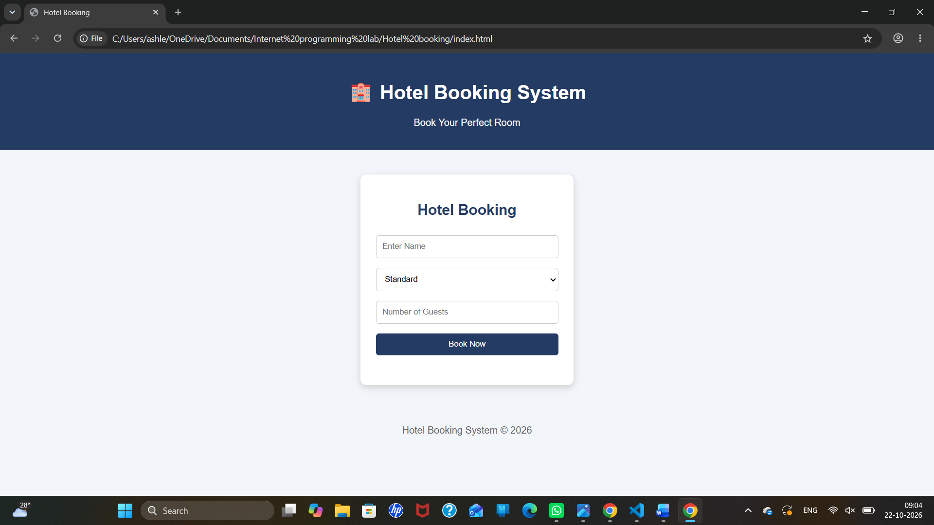

Result
Thus, the Hotel Booking webpage was created successfully with fields for customer name, room type, and number of guests, along with a Book Now button.

